How does the Simple Customer Relationship Management (CRM) System work?
This Simple Customer Relationship Management (CRM) System can be accessed by 2 different user roles which are the Administrator and the Customers. The Administrator can access the admin panel of the system while the Customer has access to the customer side of the application.
The Administrator user is the one who is in charge of managing the important data on the system. This side of the system requires the Admin User to log in with his/her valid system credentials in order to access and manage the system on the admin side. Here, the administrator is able to read and manage the quotation requests of the customers and the same as well on the created or issued tickets of the customers. Aside from that, the admin can also list the registered customers' accounts.
The Customers are required to signup and log in to the system in order to gain access to the different features and functionalities on the Customer Side. They submit quotation requests and tickets. The customer can only access and manage the list of quotation requests and tickets that he or she submitted

Features and Functionalities
Here are the different features and functionalities of the Simple Customer Relationship Management (CRM) System

Admin Site
- Login and Logout
- Dashboard
  - Data Summary
  - Visitors Graph
- List and Manage Tickets
- List and Manage Customers' Quotation Requests
- List All Users' Access Logs
- List and Manage Registered Users' Accounts
- Update/Change Password

Customer Site
- Login and Registration
- Dashboard
- Create Quotation Request
- List Tickets
- Create Ticket
- View Ticket Details
- View and Manage Profile
- Update/Change Password

Technologies
Here is the list of Technologies to develop the Simple Customer Relationship Management (CRM) System:
- HTML
- CSS
- PHP
- MySQL Database
- Bootstrap Framework
- DataTables
- JavaScript
- jQuery Library
The Simple Customer Relationship Management (CRM) System Project source code zip file is provided on this website and is free to download. Feel Free to download the source code and modify it to meet your own requirements.

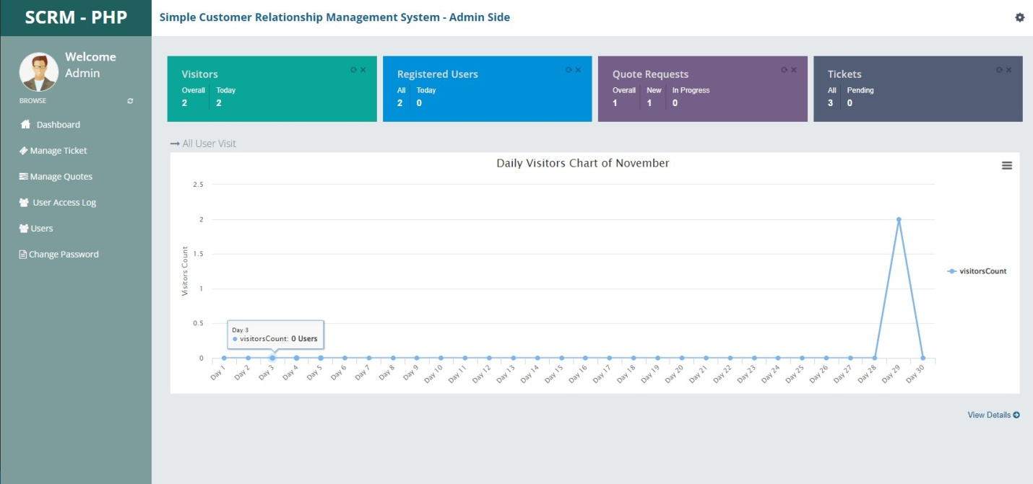

Quote Request Details (Admin)
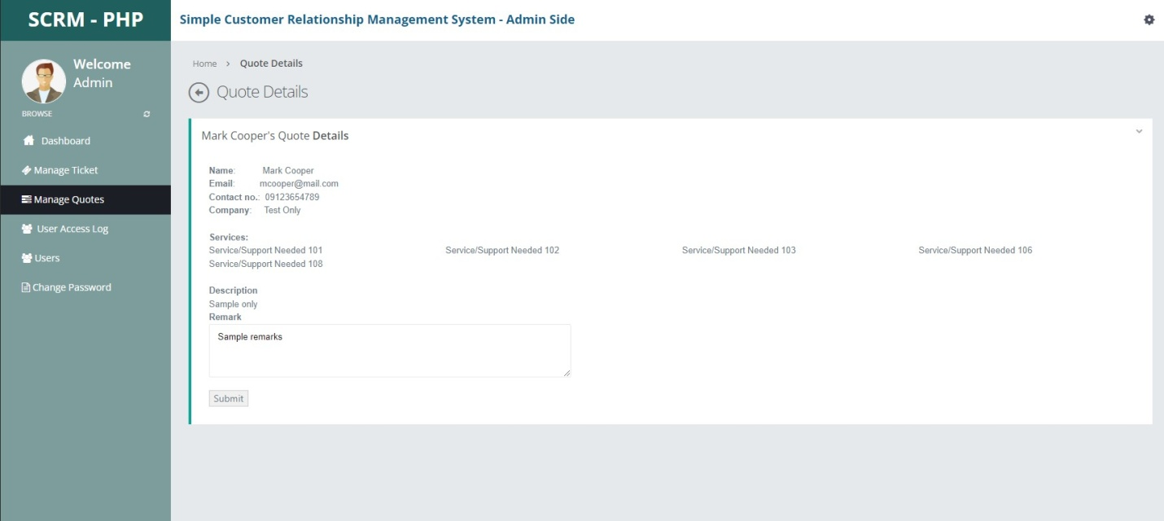

Admin Default Access:
Username: admin
Password: admin123

